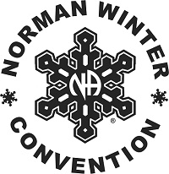
JANUARY 10-12, 2025

NORMAN WINTER CONVENTION

NEEDS YOUR SUBMISSIONS FOR SPEAKERS ASAP!

PLEASE send submissions to:
greg.beer@gmail.com

Non-digital submissions can be mailed to:
WASC
Attn: Greg B./NWC
P.O. Box 12732
Oklahoma City, Ok 73157

DEADLINE FOR SUBMISSIONS IS AUGUST 15, 2024

