South Side Recovery In Progress NA Group Presents

**FAREWELL TO SUMMER CAMPOUT**

September 20-22, 2024

Zoom Beach

Lake Thunderbird, Norman OK

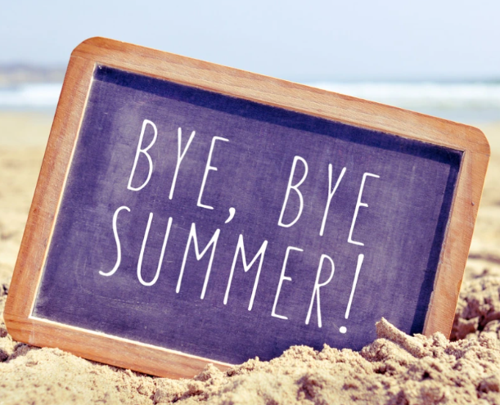

Food, Games, Fellowship

Friday Night Speaker 8:00 pm

Daisy K.

Saturday Night Speaker 8:00 pm

California Tim L.

Contact Mary E. For Additional Information: 405-778-4063